Information Redundancy
# Source: AI Source: Provided by: [Data Path: Persons Table -> ID Column: 1, Name_En Column: Motasem Essam] -> From: [ChatGPT] on [1/21/2026]
Information Redundancy is the third type of redundancy used in fault-tolerant Real-Time Systems (RTS). Unlike hardware or software redundancy, it focuses on adding extra information to detect and correct errors in data.

Definition
# Source: AI Source: Provided by: [Data Path: Persons Table -> ID Column: 1, Name_En Column: Motasem Essam] -> From: [ChatGPT] on [1/21/2026]
Information redundancy is the technique of adding extra bits or data to messages or stored data so that errors caused by faults or noise can be detected and corrected automatically.
- Ensures data integrity in real-time systems, communication, and embedded devices.
- Often used to handle transient faults, communication errors, or memory errors.

Key Features
# Source: AI Source: Provided by: [Data Path: Persons Table -> ID Column: 1, Name_En Column: Motasem Essam] -> From: [ChatGPT] on [1/21/2026]
- Redundant Data Bits
  - Extra bits are added to data to check for errors.
- Error Detection
  - Detects errors in memory, communication, or processing.
- Error Correction
  - Some codes allow automatic correction of detected errors.
- Lightweight
  - No duplication of hardware or software needed; only extra information.

Common Techniques
# Source: AI Source: Provided by: [Data Path: Persons Table -> ID Column: 1, Name_En Column: Motasem Essam] -> From: [ChatGPT] on [1/21/2026]
- Parity Bits
  - Add 1 bit to make the total number of 1s even or odd.
  - Detects single-bit errors.
- Checksums
  - Sum of data values sent along with the message
  - Receiver recalculates to verify integrity
- Error-Correcting Codes (ECC)
  - Hamming Code, Reed-Solomon, BCH codes
  - Detects and corrects multiple-bit errors automatically
- Cyclic Redundancy Check (CRC)
  - Polynomial-based method for detecting burst errors
  - Widely used in communication systems

Example
# Source: AI Source: Provided by: [Data Path: Persons Table -> ID Column: 1, Name_En Column: Motasem Essam] -> From: [ChatGPT] on [1/21/2026]
- Memory system in a satellite:
  - Data: 1011001
  - ECC adds redundant bits → stored as 1011001110
  - If one bit flips due to cosmic radiation, ECC detects and corrects the error automatically

Advantages
# Source: AI Source: Provided by: [Data Path: Persons Table -> ID Column: 1, Name_En Column: Motasem Essam] -> From: [ChatGPT] on [1/21/2026]
- Detects and corrects transient or soft errors
- No need for extra hardware or duplicate software
- Essential for communication and memory reliability

Disadvantages
# Source: AI Source: Provided by: [Data Path: Persons Table -> ID Column: 1, Name_En Column: Motasem Essam] -> From: [ChatGPT] on [1/21/2026]
- Adds extra data and processing overhead
- Complex algorithms may increase latency, critical in hard real-time systems
- Limited error correction depending on code design

Applications
# Source: AI Source: Provided by: [Data Path: Persons Table -> ID Column: 1, Name_En Column: Motasem Essam] -> From: [ChatGPT] on [1/21/2026]
- Satellite and spacecraft memory systems
- Communication protocols (CAN, TCP/IP, SpaceWire)
- Embedded control systems in automotive and aerospace
- Industrial automation sensors and controllers

Summary of Redundancy Types
# Source: AI Source: Provided by: [Data Path: Persons Table -> ID Column: 1, Name_En Column: Motasem Essam] -> From: [ChatGPT] on [1/21/2026]
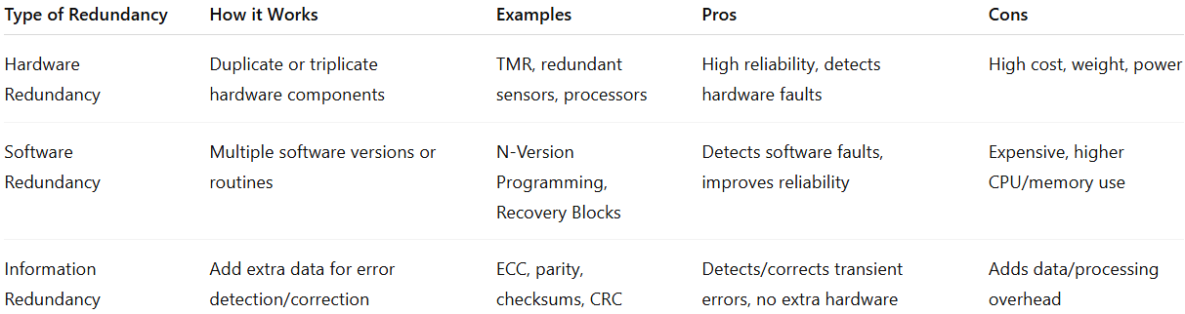
Type of Redundancy | How it Works | Examples | Pros | Cons
Hardware Redundancy | Duplicate or triplicate hardware components | TMR, redundant sensors, processors | High reliability, detects hardware faults | High cost, weight, power
Software Redundancy | Multiple software versions or routines | N-Version Programming, Recovery Blocks | Detects software faults, improves reliability | Expensive, higher CPU/memory use
Information Redundancy | Add extra data for error detection/correction | ECC, parity, checksums, CRC | Detects/corrects transient errors, no extra hardware | Adds data/processing overhead

If you want, I can create a full diagram showing all three redundancy types—hardware, software, and information—with examples in real-time systems, which makes it very easy to understand visually.
Do you want me to make that diagram?

